Laravel

1. **Create a Laravel Project**:

If you haven't already, you can create a new Laravel project by running:

Laravel new your-project-name

1. Starter Kit: You chose "No starter kit."
2. Testing Framework: PHPUnit
3. Git Repository: No
4. Database: MySQL

C:\xampp1\htdocs\livewire>Laravel

Laravel Installer 5.1.3

Replace **your-project-name** with the name of your project.

1. **Set up Database Connection**:

Configure your **.env** file with your database credentials:

DB_CONNECTION=mysql

1. DB_CONNECTION=mysql
2. DB_HOST=127.0.0.1
3. DB_PORT=3306
4. DB_DATABASE=laraveladit1
5. DB_USERNAME=root
6. DB_PASSWORD=
7. **Create a Migration**:

Run the following command to generate a migration for your table:

php artisan make:migration create_items_table

This will create a new migration file in the **database/migrations** directory.

1. **Define Schema in Migration**:

Open the newly created migration file (**create_items_table.php** in this example) and define the schema for your table inside the **up** method:

    public function up()

    {

        Schema::create('items', function (Blueprint $table) {

            $table->id();

            $table->string('name');

            $table->text('description');

            $table->timestamps();

        });

    }

1. **Run Migration**:

Run the migration to create the table in your database:

php artisan migrate

if you got any issue then chage the database name.

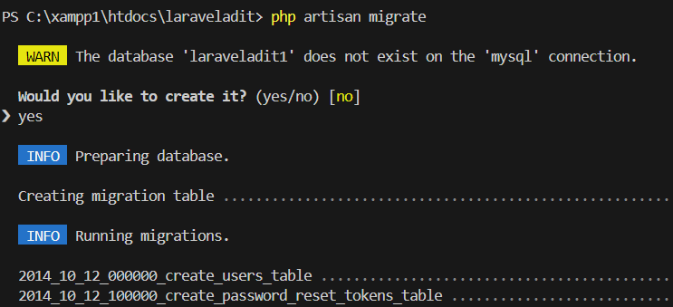

1. **Create Model**:

Create a model for your **Item**:

go

php artisan make:model Item



1. **Create a Controller**:

Generate a controller to handle the form:

go

php artisan make:controller ItemController



1. **Define Routes**:

Open **routes/web.php** and define the routes for your form:

php

Route::get('/items/create', [App\Http\Controllers\ItemController::class, 'create']);

Route::post('/items/store', [App\Http\Controllers\ItemController::class, 'store']);

1. **Create Form View**:

Create a blade view file **resources/views/items/create.blade.php** and define your form:

<!DOCTYPE html>

<html lang="en">

<head>

    <meta charset="UTF-8">

    <meta name="viewport" content="width=device-width, initial-scale=1.0">

    <title>Form with Bootstrap</title>

    <!-- Bootstrap CSS -->

    <link href="https://stackpath.bootstrapcdn.com/bootstrap/5.1.3/css/bootstrap.min.css" rel="stylesheet">

</head>

<body>

<div class="container">

    <h1 class="mt-5">Form Example with Bootstrap</h1>

    <form action="/items/store" method="post" class="mt-3">

        @csrf

        <div class="mb-3">

            <label for="name" class="form-label">Item Name</label>

            <input type="text" name="name" class="form-control" id="name" placeholder="Enter item name">

        </div>

        <div class="mb-3">

            <label for="description" class="form-label">Item Description</label>

            <textarea name="description" class="form-control" id="description" placeholder="Enter item description"></textarea>

        </div>

        <button type="submit" class="btn btn-primary">Submit</button>

    </form>

</div>

<!-- Bootstrap JS -->

<script src="https://cdnjs.cloudflare.com/ajax/libs/bootstrap/5.1.3/js/bootstrap.bundle.min.js"></script>

@if(session('success'))

<script>

    // Display an alert with the success message

    alert("{{ session('success') }}");

</script>

@endif

</body>

</html>

1. **Implement Controller Methods**:

Open **app/Http/Controllers/ItemController.php** and implement the **create** and **store** methods:

<?php

namespace App\Http\Controllers;

use Illuminate\Http\Request;

use App\Models\Item;

class ItemController extends Controller

{

    public function create()

    {

        return view('items.create');

    }

    public function store(Request $request)

    {

        $item = new Item();

        $item->name = $request->input('name');

        $item->description = $request->input('description');

        $item->save();

        return redirect('/items/create')->with('success', 'Item created successfully!');

    }

}